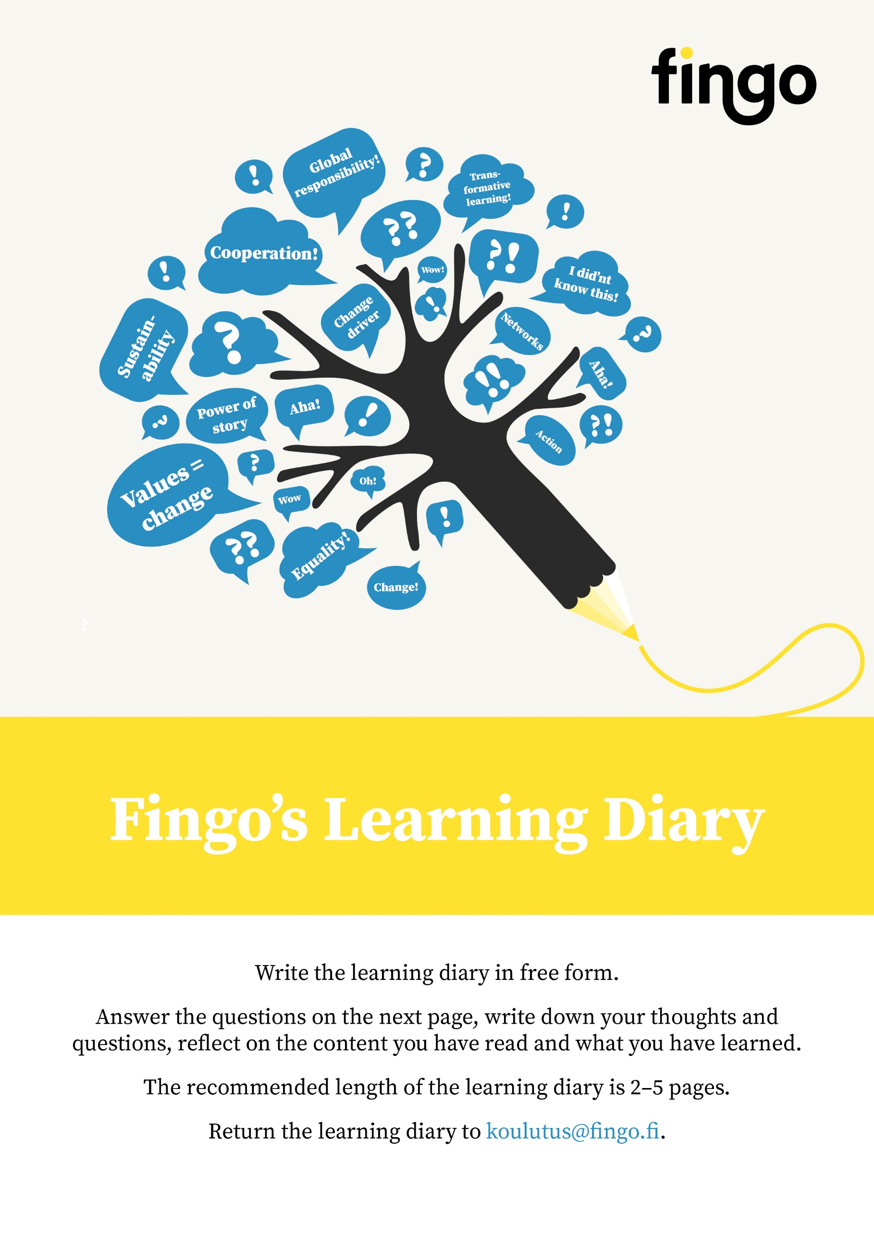
Participant information
Course/Training title
Name of the participant
Organisation
E-mail address

Please answer at least the following questions in your learning diary:
- What thoughts or new ideas did you have after reading the course material?
- Was it all clear to you? What did you not understand?
- Do you disagree with some of the content?
- Did the materials shape the way you think and act in the world? How?
- What topics would you like to learn more about in the future? Where or from whom could you get more information on those topics?
- How are you going to apply what you have learned to your own work / volunteer work / other activities?

Download the template and save it to your own computer. Start writing on the next page.

Learning diary

